Mini-Hackathon Participant Instructions
Closed-Loop Control Implementation & Telemetry Logging
PARTICIPANT CHECKLIST: Prerequisites: You will be implementing an iterative control policy inside standard Gymnasium environment to align the beam.
Submission: Once complete, run evaluate_hackathon_benchmark(...) to sync results with the shared Leaderboard on GDrive and W&B.

Visual Schematic of the Core Beamline
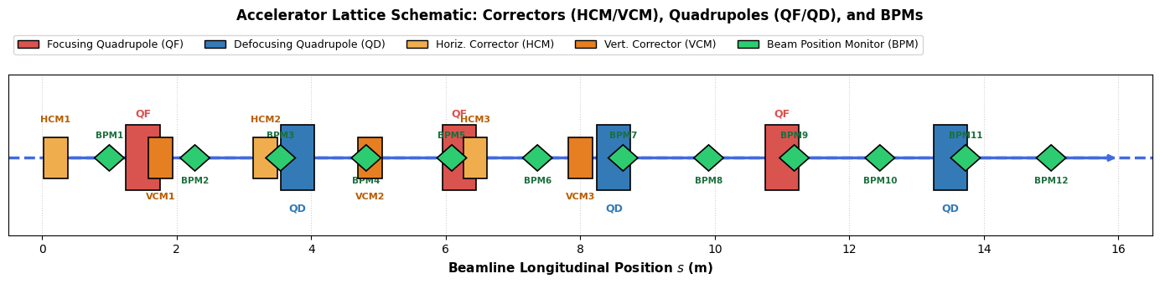
Schematic: Dipole correctors (HCM/VCM), magnetic focusing (QF/QD), and measurement diagnostics (BPMs).

Step-by-Step Milestones
- Step 1: Open Single_Notebook_Beam_Orbit_Predictor_Participant.ipynb in Colab/Docker and complete standard environment dependencies.
- Step 2: Install wandb and call wandb.login() to bind your individual key.
- Step 3: Complete TODO 1 by training Ridge linear model & multi-layer MLP surrogate forward digital twin.
- Step 4: Solve TODO 2 by designing a closed-loop RL feedback policy agent with physics priors and adaptive damping.
- Step 5: Solve TODO 3 by implementing a sample-efficient Bayesian Optimization controller using GaussianProcessRegressor with Lower Confidence Bound (LCB) acquisition.
- Step 6: Submit via evaluate_hackathon_benchmark and visual dynamic convergence curve overlays.

